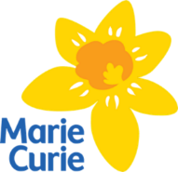

Community Pharmacy Quality Improvement (“Daffodil”) Standards
for Palliative and End of Life Care

Training Needs Assessment (November 2022)
We suggest that assessment of training needs follows the standard Continuing Professional Development (CPD) Cycle, described below.
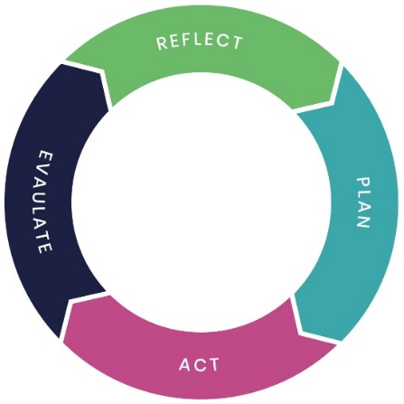
Fig 1. The CPD cycle
REFLECT
Consider what areas of activity EACH individual in the team needs to be confident and competent to perform. This can be done by identifying the GAP between the current level of confidence/competence for each individual (by name or by the role they fulfil) and the desired level, in each of the activities listed in Table 1.
PLAN
List the learning needs identified in the above activity. You can collate the list of training identified on the template Training Needs Assessment i.e. Table 2. It may be helpful to consider the available resources to help address the training needs and the best way to deliver them e.g. presentation, group discussion, e-learning or a combination of methods. The attached LINK takes you to a full range of resource materials which may be helpful.
Agree realistic SMART objectives (Specific, Measurable, Achievable, Realistic and Timely) for reviewing training needs of staff. Agree the plan with your team members, including the timescale for action.
ACT
Ensure staff members are supported through their training. Wherever possible, schedule some “protected learning time” to help demonstrate the importance of this training to individuals and team effectiveness.
EVALUATE
Confirm that the actions have resulted in addressing the identified gap(s). If not, then clarify the learning needs and create a new entry on your Training Needs Assessment (Table 2).

Table 1: Desired Learning Outcomes
End of Life Care Skills Education and Training Framework sets out the core knowledge and skills required to provide end-of-life care. It has three tiers reflecting the different roles and responsibilities people have in providing care. These are Tier 1, for those that require general end-of-life care awareness e.g. health care assistants (Tier 2), for those health and social care professionals providing a person-centred care and who often encounter individuals who need such support in their working environment e.g. community pharmacists, and Tier 3 for more specialist roles in this area.
Tier 1: Those that require general end of life care awareness, focusing on a community development, asset-based approach to care
The learner will:
a) be able to engage in conversation with an individual nearing the end of life
b) understand and respect that individuals are experts in their own lives
c) understand and be willing to support the diverse needs and wishes of individuals, that may differ from your own
d) understand that person-centred care includes all elements of an individual’s life that are important to them, not just their symptoms
e) understand who is important to the individual and who they see as ‘leading’ their care
f) understand the part you play in the individual’s end of life care and know where to seek support
g) understand importance of a caring network from which the individual and those important to them may benefit

Tier 2: Health and social care professionals who require some knowledge of how to provide person-centred, high quality end of life care as they often encounter individuals who need such support within their working environment.
The learner will:
a) understand how to make the individual the focal point of their own care and support, prioritising individuals’ wishes and beliefs to support them to retain independence, choice and dignity
b) be able to empower and support individuals manage their care and support and to make decisions based on their own experience, utilising professional support and guidance
c) be able to assess the needs, concerns and priorities of individuals and those important to them in a person-centred way, and support them to meet these needs
d) be able to support individuals to identify and manage risk
e) be able to work with individuals and others to develop a person-centred end of life care plan that balances disease-specific treatment with care and support needs and wishes of the individual

Table 2. Training Needs Assessment Template
Staff name  (or role) | Learning need(s) identified | Action to address need | Agreed timescale | Person responsible | Date completed | Comment e.g. feedback, any further action needed

